Download cypress.7z from svn

<https://svn.code.sf.net/p/jaer/code/trunk/deviceFirmwarePCBLayout/CypressFX2>

and unzipp in C:\

Install a full version of Keil uVision (C51 compiler) from Keil ARM webpage

Open Keil, go to Project/Manage/Components… and fill the gaps as follows:

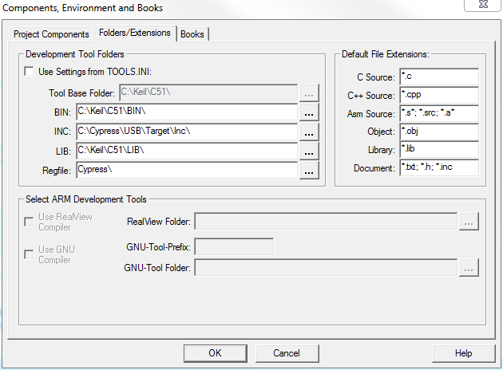

Enjoy!